(Final) SUMMARY MINUTES FROM September 6, 2017 VLITE BOARD of DIRECTORS MEETING:
Prepared by Paul Craven, ED

VLITE Board of Directors Meeting
September 6, 2017
Sheraton Hotel (Burlington, VT)
(1:45 PM – 3:00 PM)

In attendance:
Board members: Dick Marron, Richard Rubin, Pat Moulton, Hal Cohen, Scott Johnstone & Chuck Ross

Summary meeting minutes:

A motion was made to approve the draft minutes from the May 10, 2017 Board of Directors meeting.

1st Pat Moulton, 2nd Richard Rubin
All in favor: yes 6, 0 no, 0 abstain

Treasurers report

A motion was made to approve the VLITE (8/22/17) Balance sheet & Profit & Loss Statement.

1st Richard Rubin, 2nd Hal Cohen
All in favor: yes 6, 0 no, 0 abstain

VLITE ongoing grant funding update: Paul Craven
    - Grant’s status report
    - Grant closures in this quarter

Board discussion with select panel on FY 2017 & FY 2018 funding initiatives:
Joining Board members: Kerrick Johnson (VELCO), Neile Lunderville (BED Gen Mgr),
Brian Otley (COO GMP), Chad Farrell (Renewable Developer), Karen Glitman (Efficiency Vermont)

Summary:
Since VLITE began issuing grants in 2013, VLITE’s strategy has been to support projects (see attached: VLITE funding to date / approximately 5 Million dollars) that can be transformational —that can serve as models and open new pathways for renewable technologies, efficiency measures, education and outreach programs.

SUMMARY comments from Panel Members:
Neale Lunderville:
Biggest challenge disparity people of low and modest income and more affluent neighbors. Goal of the study – equal access to all Vermonters. Three parts: 1) analysis and inventory, 2) Guide and checklist, 3) energy access coalition’
- Analysis and inventory: create an online repository of efforts in renewable and distributed energy and transportation. Lessons learned, key components and replicability
- Create a how-to business guide for the energy industry, including a check list of steps to ensure to innovations and technology and devise the best financial instruments.
- Mirroring the success of the housing coalition, convene an energy action coalition. Create a small diverse task force.
Kerrick Johnson:
Entrepreneur uplift – leverage accelerator initiative to add value and increase chances of success for winners.
Collaborative planning – leverage work by entity such as VCRD & VSJF to not just eliminate obstacles but to engage and build support for CEP outcomes.
Solution analysis engage in the funding for analysis of solutions that solve those issues that arise as a result of CEP pursuit. Conflicting with federal market requirements.
Karen Glitman:
Develop a program – workforce development, supply chain, to build a factory to build panel & modular net zero homes (awareness outreach & incentives)
Leverage funds to go all in on electrification in the Northeast region (electric school bus, electric transit buses. This is an economically disadvantaged region
Impact – don’t spread dollars thinly. Use dollars to transform markets so that VLITE can accelerate access to clean affordable and efficiency energy (electric, thermal, & transport) for all Vermonters to meet their daily needs.
Tom Otley:
Use small VLITE grants (250k) to help close the gap between what low income customers currently pay to power, heat, cool, their inefficient homes and what they would pay to perform an energy transformation and lower their energy costs.
Neale’s idea of bonding to expand funding was a good idea.
Estimate - $5,000 / home in Panton project cost buy down.

Summary – best investment

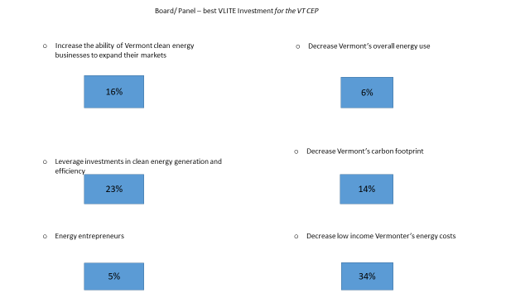

Energy Action Network discussion:

- Meeting Closure 3:00 PM

